For our lab on the photoelectric effect, we will be using the following simulation:
https://www.thephysicsaviary.com/Physics/Programs/Labs/PhotoelectricEffect/
Once you launch the simulation, you will see a screen like this:
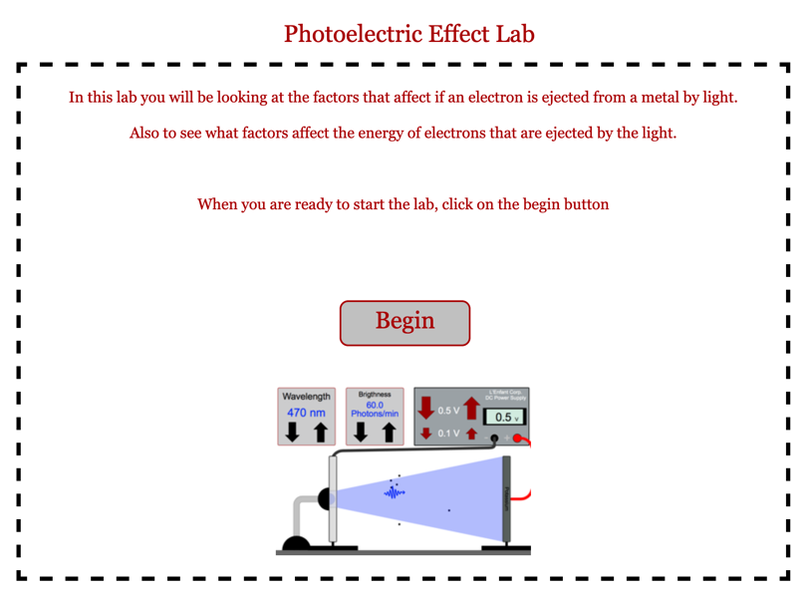
Notice that there are controls for the wavelength of light (rather than the frequency); the brightness – or intensity – as measured by the number of photons/min; and for the applied voltage. The voltage can be changed by either 0.1 V or 0.5 V at a time.
Once you open the simulation, you should see the following default settings:
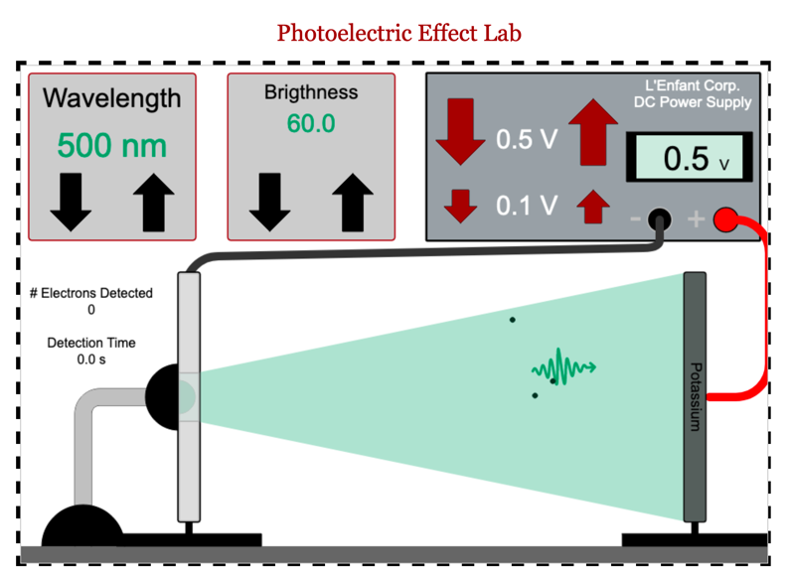
Notice that below the wavelength controls, there are readouts for the number of electrons detected, and the detection time. There is, however, no pause button, and the timer will only begin if electrons are emitted, and detected by the detector on the left. If no electrons are detected, we will record the current as zero. Be patient! It takes a few seconds in the simulation for electrons to be emitted, and then to cross the gap to be detected. We can use this information to calculate current:
$$I=\frac{Ne}{∆t}$$
Where N is the number of electrons, e is the charge of one electron.

Varying Wavelength
For this part of the experiment, we will be examining the effects of changing wavelength on the number of electrons emitted from the surface of potassium.
To set this up,
- Use the controls to set the voltage to zero.
- Turn up the brightness to its maximum setting.
- Set the wavelength to 600 nm. This is on the red side of the visible spectrum.
- For each measurement, be sure to collect data for 30 seconds or more.
- Now complete the following measurements using the simulator. Here, your goal is to find the cutoff wavelength (and therefore, the cutoff frequency) – in other words, the wavelength at which the current changes from zero to non-zero. You should be sure to collect enough data to be sure that you know at what wavelength this will occur.
Wavelength (nm) | # electrons detected | Detection time | Frequency (Hz) | Current (A)
600 | 0 | 0 | 0.5 | 0
550 | 0 | 0 | 0.55 | 0
540 | 0 | 0 | 0.56 | 0
530 | 60 | 30 | 0.57 | 2
520 | 66 | 30 | 0.575 | 2.2
510 | 62 | 30 | 0.59 | 2.1
500 | 70 | 30 | 0.6 | 2.3
490 | 72 | 30 | 0.62 | 2.4
480 | 68 | 30 | 0.625 | 2.3
470 | 69 | 30 | 0.635 | 2.3
460 | 70 | 30 | 0.65 | 2.3
450 | 68 | 30 | 0.67 | 2.3
440 | 68 | 30 | 0.68 | 2.3
430 | 70 | 30 | 0.695 | 2.3
420 | 70 | 30 | 0.71 | 2.3
410 | 66 | 30 | 0.73 | 2.2
400 | 72 | 30 | 0.75 | 2.4

- Next, create a graph of current vs. frequency. Be sure to label the axes. Insert that graph here. Identify, using the data table and the graph, what the cutoff frequency is.

Cutoff Frequency

- Beyond the cutoff, does the current appear to be increasing, decreasing, or staying the same? Test your hypothesis by collecting some more current data in that same range of wavelengths to see if it holds true.
Beyond the cutoff frequency the current appears to increase up to a certain point then stops.
Now let’s repeat the experiment, but with a different metal. Brightness should remain at maximum, and voltage at zero. Switch metals by clicking on the electrode connected to the red wire, with the label reading potassium, until it now reads sodium.
- Again, complete the following measurements using the simulator. Here, your goal is to find the cutoff wavelength (and therefore, the cutoff frequency) – in other words, the wavelength at which the current changes from zero to non-zero. You should be sure to collect enough data to be sure that you know at what wavelength this will occur.
Wavelength (nm) | # electrons detected | Detection time | Frequency (Hz) | Current (A)
600 | 0 | 0 | 0.5 | 0
550 | 0 | 0 | 0.55 | 0
540 | 0 | 0 | 0.56 | 0
530 | 0 | 0 | 0.57 | 0
520 | 0 | 0 | 0.575 | 0
510 | 0 | 0 | 0.59 | 0
500 | 0 | 0 | 0.6 | 0
490 | 0 | 0 | 0.62 | 0
480 | 0 | 0 | 0.625 | 0
470 | 0 | 0 | 0.635 | 0
460 | 0 | 0 | 0.65 | 0
450 | 68 | 30 | 0.67 | 2.3
440 | 69 | 30 | 0.68 | 2.3
430 | 68 | 30 | 0.695 | 2.3
420 | 68 | 30 | 0.71 | 2.3
410 | 70 | 30 | 0.73 | 2.3
400 | 68 | 30 | 0.75 | 2.3

- Next, create a graph of current vs. frequency. Be sure to label the axes. Insert that graph here. Identify, using the data table and the graph, what the cutoff frequency is.

Cutoff Frequency

- How are the two graphs (from question 2, and question 5) similar to each other?

The two graphs are similar in that when they reach the cutoff frequency the frequency is somewhat constant. Also, the current in both the graphs is almost the same.

- How are the two graphs different?
The cutoff frequency of the second graph is lower than the cutoff frequency of the first graph.

Varying Brightness
For this part of the experiment, we will be examining the effects of changing brightness on the number of electrons emitted from the surface of potassium.
To set this up, first reset the simulation to the original settings.
- Use the controls to set the voltage to zero.
- Turn up the brightness to its maximum setting.
- Set the wavelength to 470 nm.
- Make sure that you have reset the metal back to potassium.
- For each measurement, be sure to collect data for 30 seconds or more.
- Now, as we decrease the brightness of the light, record the # electrons and detection time, and calculate the current. Then you will increase the brightness of the light from 0 to the maximum, following the same process.
Brightness (photons/min) | # electrons detected | Detection time | Current (A)
120 | 60 | 30 | 2
110 | 60 | 30 | 2
100 | 58 | 30 | 1.9
90 | 43 | 30 | 1.5
80 | 42 | 30 | 1.4
70 | 38 | 30 | 1.3
60 | 36 | 30 | 1.2
50 | 33 | 30 | 1.1
40 | 18 | 30 | 0.6
30 | 13 | 30 | 0.4
20 | 10 | 30 | 0.35
10 | 8 | 30 | 0.3
0 | 0 | 0 | 0
10 | 8 | 30 | 0.3
20 | 11 | 30 | 0.4
30 | 14 | 30 | 0.5
40 | 18 | 30 | 0.6
50 | 33 | 30 | 1.1
60 | 36 | 30 | 1.2
70 | 38 | 30 | 1.3
80 | 42 | 30 | 1.4
90 | 43 | 30 | 1.4
100 | 58 | 30 | 1.9
110 | 60 | 30 | 2
120 | 60 | 30 | 2

- Next, create a graph of current (dependent) vs. brightness (independent). Be sure to label the axes. Add a trendline, and the equation for the trendline. Insert that graph here.
trendline
The formula of the trendline is Current= k Brightness
- What trends do you observe as the brightness decreases?
As the brightness decreases the current similarly decreases.

Varying the metal
For this part of the experiment, we will be examining the effects of changing the metal on the number of electrons emitted.
To set this up, first reset the simulation to the original settings.
- Use the controls to set the voltage to zero.
- Turn up the brightness to its maximum setting.
- Make sure that you have reset the metal back to potassium.

- For each metal, we are going to determine the maximum wavelength that produces a current for each metal, and use that information to calculate that metal’s work function.
Metal | Wavelength (nm) | Frequency (GHz) | Calculated Work Function (eV)
Potassium | 530 | 0.5656 | 2.339
Platinum | 210 | 1.37 | 5.661
Sodium | 450 | 0.662 | 2.755
Silver | 260 | 1.153 | 4.768
Cesium | 580 | 0.5169 | 2.137
Gold | 230 | 1.3034 | 5.390
Copper | 250 | 1.1992 | 4.960

- Look up the value for the work function for each metal. Find the percent error for each.
Metal | Calculated Work Function (eV) | Theoretical Work function | % error
Potassium | 2.4 | 2.3 | 4.347%
Platinum | 2.4 | 6.35 | 62.204%
Sodium | 2.4 | 2.28 | 5.263%
Silver | 2.4 | 4.26 | 43.662%
Cesium | 2.4 | 2.1 | 14.286%
Gold | 2.4 | 5.1 | 52.941%
Copper | 2.4 | 4.7 | 48.936%

Varying the applied voltage
For this part of the experiment, we will be examining the effects of changing the applied voltage on the number of electrons emitted, and determining if that changes based on the wavelength of the light.
To set this up, first reset the simulation to the original settings.
- Use the controls to set the voltage to zero.
- Turn up the brightness to its maximum setting.
- Make sure that you have reset the metal back to potassium.

- For potassium, we are going to determine the applied voltage at which NO electrons are detected, as a function of the wavelength of light that is shining on the metal. To do this, you will
  - first set the wavelength of light shining on the potassium surface
  - next, slowly increase the voltage applied. You will have found the “stopping voltage” when the photoelectrons emitted from the potassium surface do not quite reach the detector, so that no current at all is detected.
  - Then you will calculate the frequency of the photons, and from there, use the frequency to calculate the photon energy in eV.
Wavelength (nm) | Stopping voltage (Volts) | Frequency (GHz) | Photon energy (eV)
200 nm | 4 | 1.5 | 6.200
250 nm | 2.7 | 1.19 | 4.960
300 nm | 1.7 | 1 | 4.132
350 nm | 1.3 | 0.8 | 3.542
400 nm | 0.8 | 0.7 | 3.100

- Create a graph of the stopping voltage (on the x-axis) vs. the photon energy (on the y-axis). Create a trendline, and insert the equation of the line. Be sure to label axes on your graph. Insert a screenshot of that graph here.

- Using the equation for your trendline, determine the work function for potassium. Show how you get this value from the equation for your trendline.
The work function of potassium is change in x/ change in y

((1.19-1)/ (4.960-4.132)) =0.19/0.828=2.29x10⁻¹

- Compare the work function you determined using the graph here with the work function for potassium you found in question 11, and to the theoretical value you found in question 12.
They are almost similar.

